Figure 5. The deformation electron density (a), total electron density (b), net spin electron density (c), and electronic density of states (DOS) (d) of the VLi₈ cluster for the lowest-energy structure. The surface isovalue for molecular orbital plotting is 0.3 e/Å³. The DOS is obtained by Gaussian extension applied to the eigenvalues and the broadening width parameter is chosen to be 0.1 eV. Spin-up (positive) and spin-down (negative) densities are given and the dashed lines indicate the location of the HOMO level.

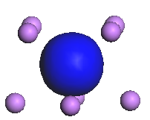
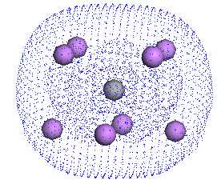
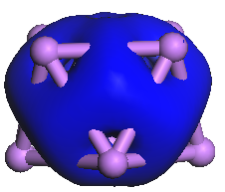
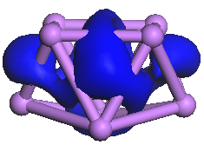

a1 (VLi₈)
b
c
a2 (Li₉)

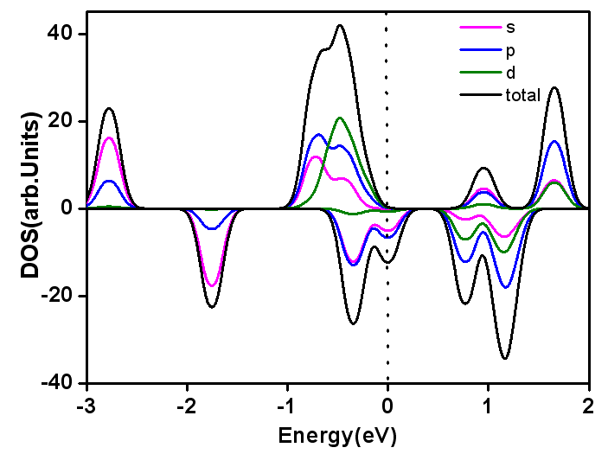

d

